LAB MANUAL

PART A

(PART A: TO BE REFFERED BY STUDENTS)

**Experiment No-09**

**A.1 Aim:** Analyze competitor activities using social media data

| **Lab Objective** | To design and develop social media analytics models. |
| --- | --- |
| **Lab Outcome** | Design and develop content and structure based social media analytics models.  Design and implement social media analytics applications for business |

**A-2 Prerequisite**

**A.3 OutCome**

Students will be able to collect, monitor, store and track social media data.

**A.4 Theory:**

Competitive analysis is more than just comparing yourself to others. And it’s definitely not about copying the competition. By analyzing the competition with a social media competitive analysis, you uncover valuable insights that empower you to improve your social strategy, and your entire business. After all, keeping an eye on the competition has cross-org benefits.

How to perform a social media competitive analysis:

1. Identify your social media competitors

2. Gather platform-specific data

3. Analyze competitors’ social media strategy

4. Step up your competitive analysis with social listening

5. Using your social media competitive analysis template and data

## **1. Identify your social media competitors**

Look to brands in your industry who are active on social media. These are brands whom you can learn from and benchmark against.

Your **direct competitors** on social are brands that sell the same products as you. Let’s use our fictional coffee company, Sprout Coffee, as an example: La Colombe, Peet’s Coffee, Caribou and local coffee shops are all direct competitors.

But also take note of **indirect competitors**. These brands may not sell the same product, but fill a similar need and reach a similar audience. For Sprout Coffee, that would be grocery stores or local cafes selling food and coffee.

### **How to ID your social media competition**

For lack of a better term: Google it! Searching for the keywords consumers would use to find your business is one of the best ways to [**uncover competitors**](https://sproutsocial.com/glossary/competitive-intelligence/). For Sprout Coffee, you might Google “ground coffee” or “instant coffee.”

Look for websites that are in your specific industry. In our example, La Colombe and Folgers could be good options. Then, explore their active social channels. For instance, Peet’s Coffee is a popular coffee company that’s very active on social media, so it makes sense to add them to our analysis as well.

## **2. Gather platform-specific data**

Let’s take a look at how to compare your brand to competitors’ social media presence on Instagram, Twitter and Facebook—the networks Sprout’s reports cover. Use these walkthroughs to guide what data you should pull for other networks too, like TikTok or LinkedIn.

### **Instagram competitive analysis**

Start by doing a visual analysis of your competition’s Instagram account. Ask yourself:

* Do they use a [**link in bio tool**](https://sproutsocial.com/insights/link-in-bio-instagram-tool/)? How often are they updating it?
* About how often are they active on stories? What does that content look like?
* Do they have a brand-specific hashtag?
* What do they say in their bio to set themselves apart?
* Are they using Instagram highlights?

Level up by using Sprout’s [**Instagram Competitors Report**](https://sproutsocial.com/insights/instagram-competitors-report/) to compare and benchmark your brand against competitors at a glance in key areas:

* **Audience growth:** Are your competitors growing their audience quicker than you?
* **Media sent:** How frequently are your competitors publishing? This can reveal whether you’re posting enough to keep your audience engaged.
* **Engagement:** How many likes and comments does your competitor content get?
* **Hashtags:** What hashtags do your competitors use to gain more exposure?
* **Top posts:** Try to get an idea of why these posts are performing well. Are they product photos? Do they use certain colors? Find out what these posts have that your content doesn’t and use the info to improve your images and videos.

**Pro tip:** Another tactic is to do a search for your competitors by hashtag on Instagram, like #Folgers, to see how many people are tagging your competitors in posts. If it’s a lot, that’s an indication the company is getting noticed and has an active following.

This will also give you a sense of what hashtags people use to refer to other brands and could potentially spark ideas for hashtags to use for your brand.

Once you have all the information from your Instagram competitive analysis research, make sure you add that data [**to your spreadsheet**](https://docs.google.com/spreadsheets/u/1/d/1Pu4tWzSdYEDIbXqWS85TqjY1ASOeuZKqCecsuWGFNOc/copy), like so:

### **Facebook competitive analysis**

Start by doing a manual review of your competitor’s page, looking for the basics:

* Number of follows and page likes
* Any specific tabs or features they have. For example, some coffee roasters might have the [**shop section**](https://www.facebook.com/business/help/238403573454149?id=206236483305742) enabled. If we notice the same trend with other competitors, it’s likely a good sign it’s working for them.
* Look at their visuals and branding.
* Review their About section—how do they set their business and social presence apart?

A visual analysis is nice, but it only goes so deep. This is where Sprout’s [**Facebook Competitor Report**](https://sproutsocial.com/insights/facebook-competitor-analysis-report/) comes in to judge how well the competition’s content performs over time.

Use this report to see how many messages your competitors send and receive, the types of content they post (text, images or videos), engagement and the amount of received messages. All of which answers higher-level questions about your competition’s presence, and how you can stand out from it.

Include this in your spreadsheet, as well as any specific metrics that are important to your strategy.

### **Twitter competitive analysis**

Your Twitter analysis will look similar to your Facebook analysis.

Here are a few areas to take note of:

* Number of followers.
* Look at the visuals and branding of their cover image and profile picture. How often do they shift these visuals?
* Review their bio—what are they highlighting? How have they set themselves apart?
* Do they adjust their Twitter name (not their handle) for holidays like Halloween?

To see a more direct, automatic comparison between your Twitter account and your competitors, level up with Sprout’s [**Twitter analytics**](https://sproutsocial.com/features/twitter-analytics/). This compares your Twitter profiles against each other, or a competitor. Select your Twitter account, then enter a competitor for the other slot.

The report shows engagement, influence, followers gained/lost and mentions. You can change the time period, but it’s best to stick to the last 30 days to keep the data relevant.

Once you’ve looked over all the competitive social media analysis from the Twitter report, be sure to enter the data into your spreadsheet. Tracking this information can be extremely valuable down the line.

### **Level up your data**

Our spreadsheet and Sprout’s reports include Facebook, Twitter and Instagram.

But we recommend conducting a manual analysis of any additional platforms, like LinkedIn and TikTok, that are relevant to your brand and audience.

Also explore Sprout’s new competitor widgets available in the Professional and Advanced plans. These enable you to customize reports and include your data alongside competitor data in one, singular report.

## **3. Analyze competitors**

Half of [**competitive intelligence**](https://sproutsocial.com/insights/competitive-intelligence/) is quantitative. But to get a true 360 view of your competitors’ social channels, you’ll need qualitative data on how your competitors use each platform.

Start analyzing your competitors’ social strategy by focusing on these three questions:

* How active is the competition?
* What types of content do they publish?
* What’s their [**brand’s social persona**](https://sproutsocial.com/insights/interactive/brand-social-persona-quiz/)?

### **How active is the competition?**

It’s fairly easy to gauge how active brands are by answering these questions:

* When was the last time they posted?
* Are there long spans of time between each post?
* Do they respond to comments?
* How in-depth are their responses to comments?

Brands should post at least once every couple of days to be considered active. But if your competitors post several times a day more than you, you risk falling behind. For example, Twitter allows for a lot more flexibility when it comes to [**how often to post**](https://sproutsocial.com/insights/how-often-to-post-on-social-media/)—are your competitors significantly outpacing your daily Tweets?

Looking into all of this sheds light on their content strategy and customer care strategy—and where there are gaps.

### **What types of content do they post?**

According to a Q1 2023 Sprout pulse survey, **53% cited changing content formats** as a major challenge when planning and scheduling content.

Look at each competitor’s last 10 posts and calculate what percentage of them are promotional—prompt their audience to sign up, shop, etc.

This can also apply to the content formats they post. Are they posting a lot of video content? Mainly photos? Do they lean heavily on creators and user-generated content? How often do they jump on trending sounds or [**social media memes**](https://sproutsocial.com/insights/social-media-memes/)?

Use this information to see what content formats they’re using to pull ahead to cut the guesswork out of your strategy.

### **What’s their brand persona?**

Some marketers like to look at their competitor’s [**brand voice**](https://sproutsocial.com/insights/brand-voice/) when doing a social media analysis. Voice describes the tone and POV a brand uses on social media. Do they post from the brand’s perspective (we) or do they let individuals post on the brand’s behalf.

For example, the tone of the Field Museum’s social account…

…is very different from the American Museum of Natural History’s tone. They each have their own online personalities.

**Level up:** As you wrap up, take a look at your competitors’ websites, because [**content marketing and social media**](https://sproutsocial.com/insights/social-media-content-strategy/) are closely related. A lot of companies repurpose their [**blogs**](https://sproutsocial.com/insights/how-to-write-a-blog-post/) for social media content. Take a look at your competition and see how many of them maximizing their bevy of content

Once you’ve gone through each competitor, say it with me: Put the data into your social media competitive analysis template.

## **4. Step up your social media competitive analysis with listening**

If you’re new to social media competitive analysis, starting with our template will help you get familiar with your competitors’ social media performance and uncover patterns for you to tune into.

But if you’re ready to [**take your competitive analysis on social media a step further**](https://sproutsocial.com/insights/strengthen-competitive-analysis-strategy-social-listening/), tap into social listening. Social listening gives you a broader perspective of conversations related to your industry and competitors that are happening across social—even when you’re not tagged. Combined with Sprout’s network competitor reports, social listening expands your view and brings in conversations on YouTube, Reddit and the broader web.

It’s an invaluable tool to uncover gaps that you can fill, conversations to jump into and more. For example, [**Grammarly**](https://sproutsocial.com/insights/case-studies/grammarly/) uses Sprout’s social listening tools to provide cross-team insights and analyze their competitive share of voice on social. In 2021, Sprout helped them identify that their brand owned 71% of their competitive share of voice.

Sprout’s built-in competitive analysis tools also make it easy to measure your competitors’ social presence and compare it to yours.

With this template, you can identify the top competitors you want to track and include specific profiles, keywords, phrases and hashtags that you want Sprout to listen to.

To see what Sprout’s social listening tools can do for your brand, [**request a demo**](https://sproutsocial.com/features/social-media-listening/#demo) to try it for yourself.

## **5. Using your social media competitive analysis template and data**

Now that you’ve compiled all of this data, you need to put it to use. Using your brand’s [**social media analytics**](https://sproutsocial.com/features/social-media-analytics/), you can compare your profiles to the competition. That’s why we included a line for your company’s data into [**our template**](https://docs.google.com/spreadsheets/d/1Pu4tWzSdYEDIbXqWS85TqjY1ASOeuZKqCecsuWGFNOc/copy).

Your final step is to interpret the data into something others will understand by going beyond simply sharing your filled-out template. With [**data storytelling**](https://sproutsocial.com/insights/storytelling-with-data/), turn those raw numbers and insights into digestible and actionable takeaways.

Here are a few tips:

* **Use visuals.** Data visualizations, like the charts and graphs Sprout reports provide, break down data into digestible visuals.
* **Identify the most interesting points and findings.** Most don't need (or want) to see every detail. What are the key findings from your social media competitive analysis?
* **Predict questions or challenges.** Get ahead by providing solutions and answers.
* **Provide next steps.** Doing a competitive analysis of social media is one thing. But defining the “what now?” is the whole reason for doing so. With what you’ve discovered, what are your next steps to improve your content and share of voice?

It’s important to keep in mind that this social media competitive analysis isn’t for you to copy exactly what everyone is doing. Instead, it will guide you toward getting started on the right foot.

## **Dive into the data with a social media competitive analysis**

In the end, it’s all about comparing your brand’s metrics and data to the competition. Then make any necessary adjustments to get a leg up on your competitors.

PART B

(PART B: TO BE COMPLETED BY STUDENTS)

| Roll. No: A11 | Name: Janhavi Tayde |
| --- | --- |
| Class: BE-A-Comps | Batch: A1 |
| Date of Experiment: 03-04-2024 | Date of Submission: 03-04-2024 |
| Grade: | |

**B.1.Analyze the competitor activities using social media data.**

Top competitors: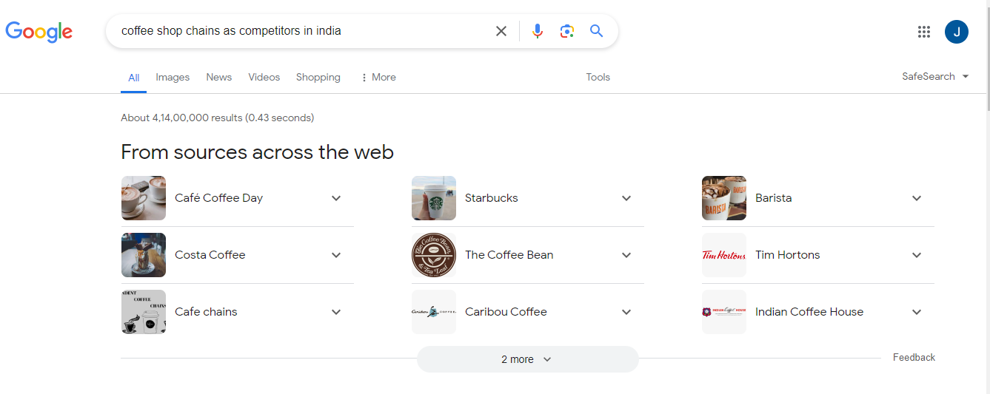

Top 5 coffee businesses on social media-

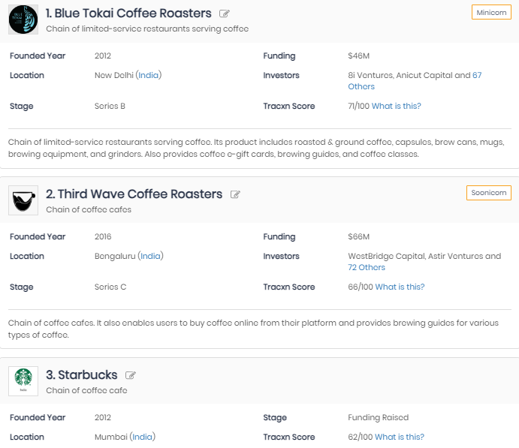

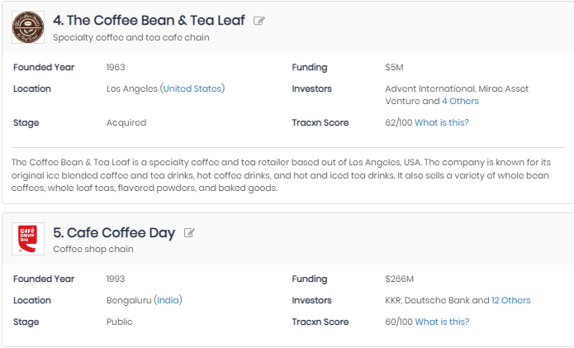

Revenues generated in 2020:

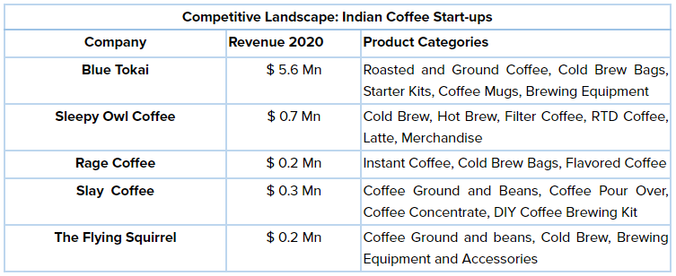

**B.2 Input and Output:**

**Comparison between the top 3 coffee businesses:**

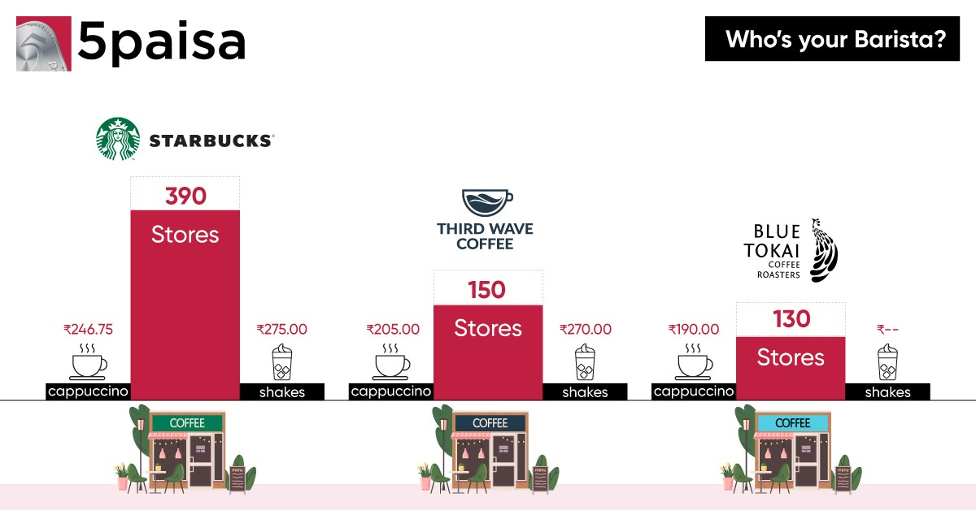

Comparing the social media presence:

1. Blue Tokai Coffee

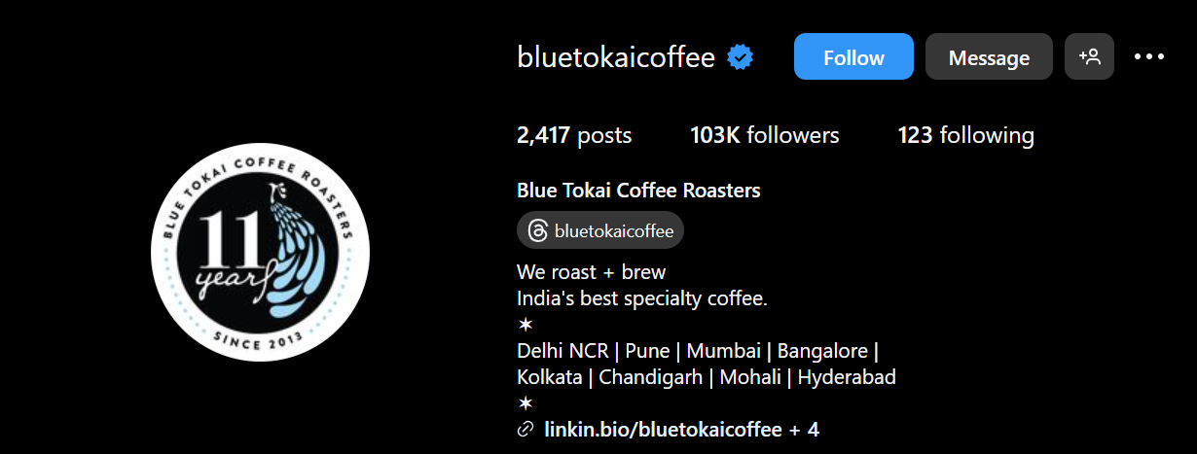

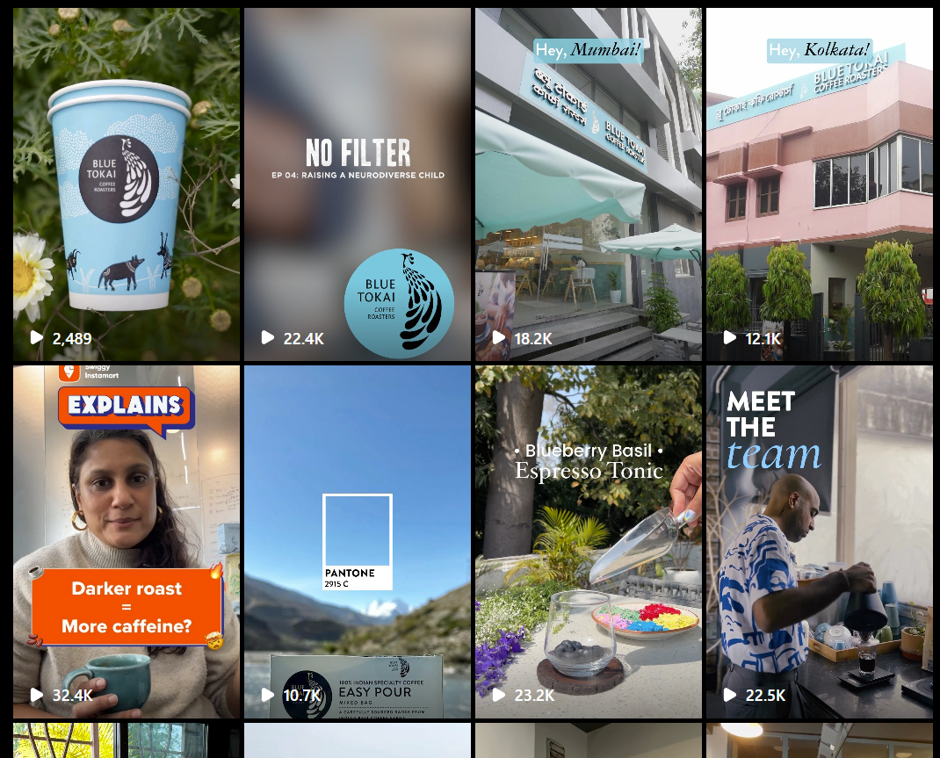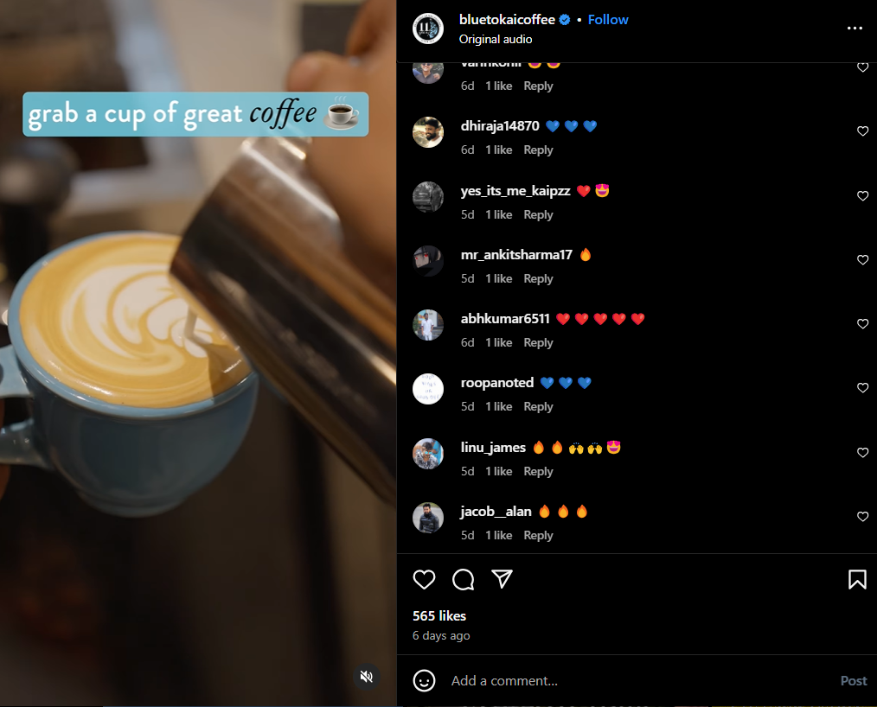

2. Third Wave Coffee:



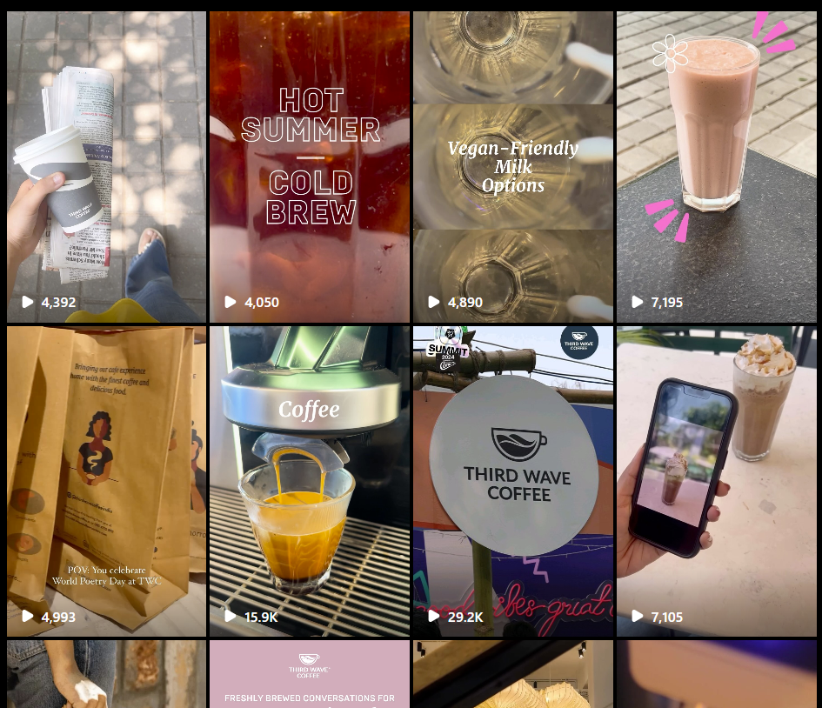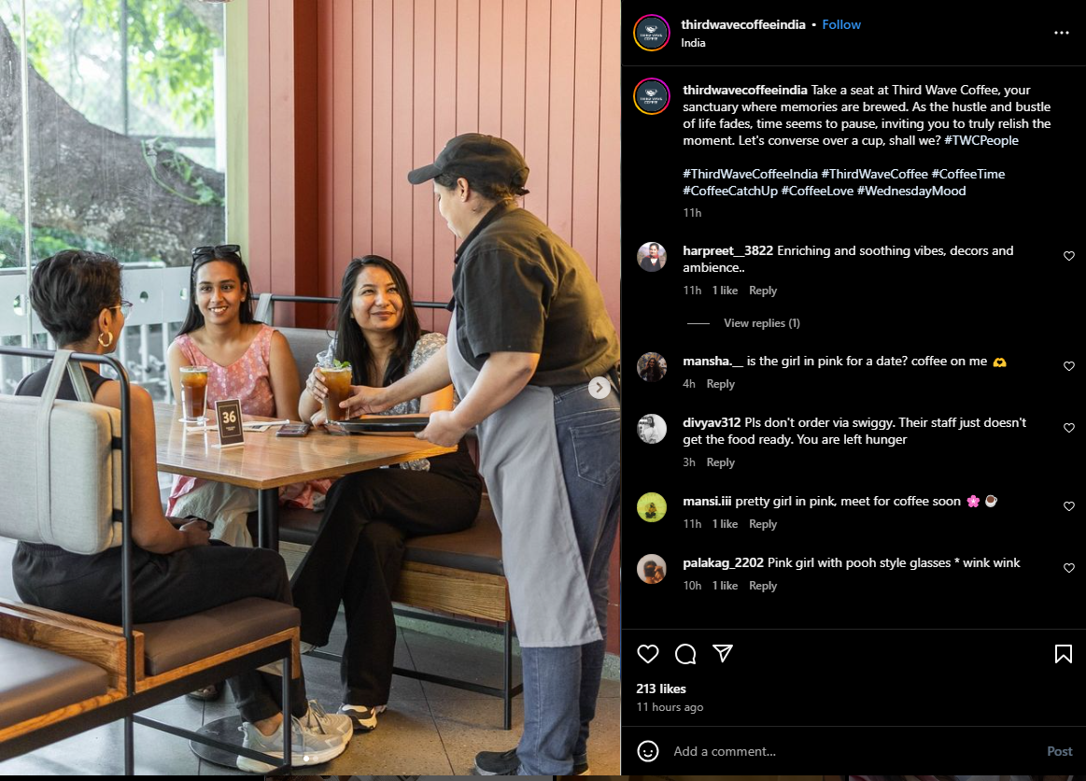

3. Starbucks India:

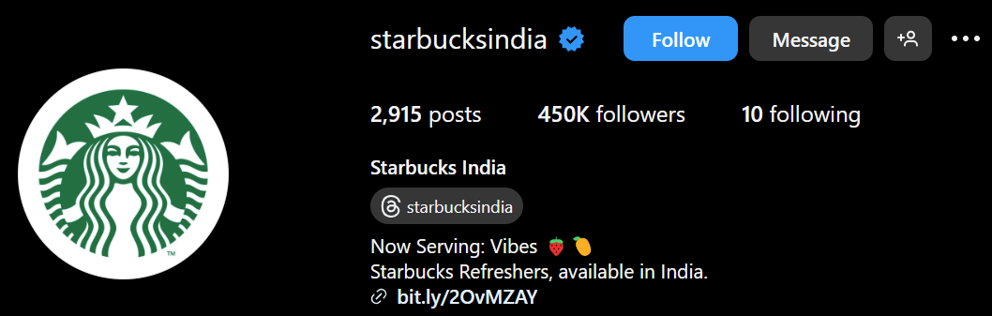

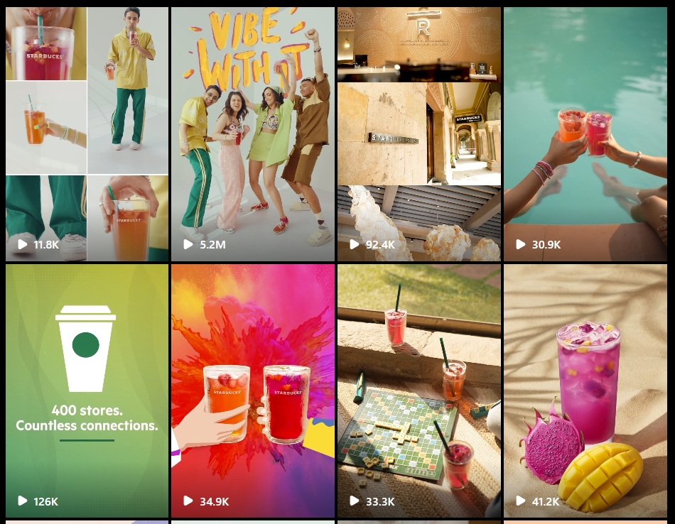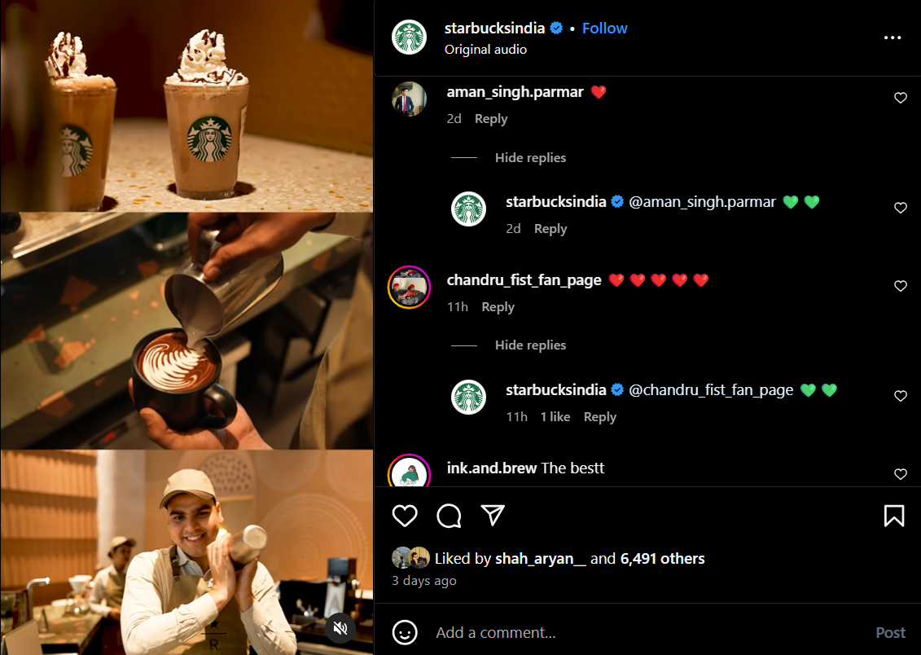

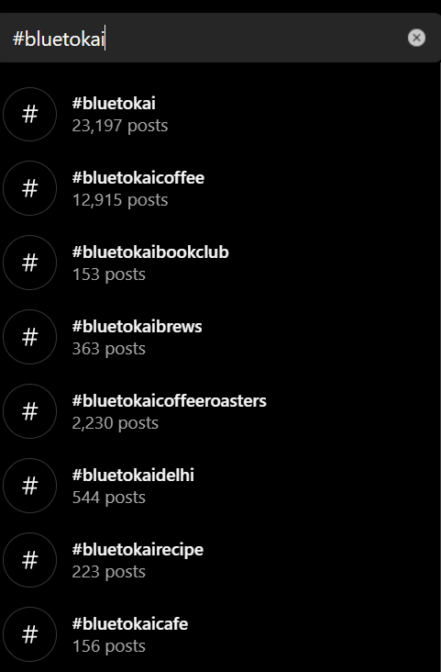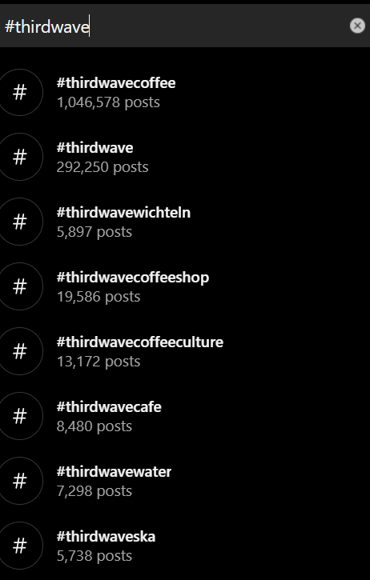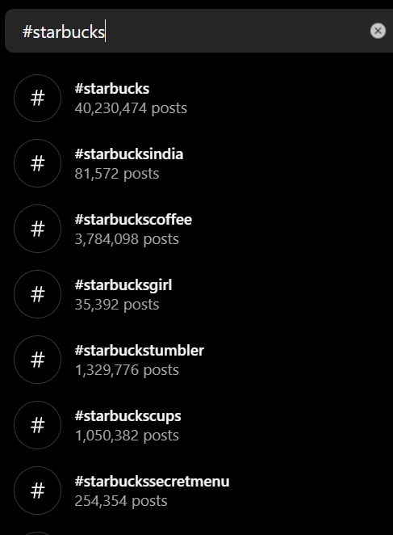

Observation-

1. Blue Tokai Coffee:

* Having 103K followers on instagram but low user engagement.
* Blue Tokai Coffee is an Indian specialty coffee roaster known for sourcing high-quality beans and offering a unique coffee experience.
* Social Media Presence: Blue Tokai maintains an active presence on platforms like Instagram, Facebook, and Twitter. They often share visually appealing content such as photos of their coffee products, brewing techniques, and behind-the-scenes glimpses of their operations. They also engage with their audience through interactive posts, coffee-related trivia, and customer testimonials.

2. Third Wave Coffee:

* With the lowest 33.3K followers, has good social media presence with lower views but very high user engagement.
* "Third wave coffee" is a broader term that encompasses a movement focused on high-quality coffee production, often involving direct relationships with coffee farmers and meticulous brewing methods.
* Social Media Presence: Third Wave Coffee shops and roasters vary widely in their social media strategies. Some may prioritize Instagram for sharing visually appealing coffee photos, while others might use platforms like YouTube to showcase brewing tutorials and educational content. Overall, their social media presence tends to emphasize coffee quality, sustainability, and community engagement.

3. Starbucks:

* Has 430K followers and very high social media user engagement.
* Starbucks is a global coffeehouse chain known for its wide range of coffee drinks, food items, and ubiquitous presence.
* Social Media Presence: Starbucks has an extensive social media presence on platforms like Facebook, Instagram, Twitter, YouTube, and LinkedIn. They use these platforms for various purposes, including promoting new products, running marketing campaigns, sharing customer stories, and engaging with their massive audience through contests, polls, and interactive content. Starbucks also leverages social media for customer service and to gather feedback.

Comparison:

* Audience Reach: Starbucks has the widest global reach due to its large number of locations and global brand recognition. Blue Tokai and Third Wave Coffee, being more niche players, have smaller but dedicated followings, often comprising coffee enthusiasts, specialty coffee lovers, and those interested in coffee culture.
* Content Strategy: Blue Tokai and Third Wave Coffee tend to focus more on coffee quality, origin stories, sustainability practices, and community building. They may share detailed information about their sourcing practices, brewing techniques, and the stories behind each coffee bean. Starbucks, on the other hand, adopts a more diverse approach, showcasing a wide range of products, promotions, and engaging with a broader audience through various content types.
* Engagement: While Starbucks may have a larger overall engagement due to its massive following, Blue Tokai and Third Wave Coffee often enjoy higher engagement rates within their specific niche communities. This is because their content resonates more deeply with their audience, who are typically passionate about specialty coffee and the values associated with it.

Blue Tokai Coffee and Third Wave Coffee target specialty coffee enthusiasts with quality, sustainability, and community focus on social media. Starbucks, with broader appeal, uses diverse content to engage a wide audience globally. While Starbucks has wider reach and engagement, Blue Tokai and Third Wave foster deeper connections within their niche.

**B.3 Observations and learning:**

Businesses are increasingly relying on sophisticated social media analytics models and applications. These tools handle diverse data types, align with specific business goals, integrate advanced technologies, provide real-time insights, foster collaboration, and undergo continuous improvement. Effective utilization empowers data-driven decision-making and drives competitive advantage in the digital market.

**B.4 Conclusion:**

In conclusion, the evolution of social media analytics models and applications reflects a paradigm shift towards data-driven strategies in modern businesses. These tools, adept at handling complex data, meeting specific objectives, leveraging advanced technologies, and offering real-time insights, have become integral for driving competitive advantage and informed decision-making in the digital landscape.

**B.5 Question of Curiosity**

Q1. What is competitor analysis?

Competitor analysis is the process of evaluating and studying the strategies, strengths, weaknesses, and performance of competitors within a specific industry or market segment. It involves gathering data and insights to understand how competitors position themselves, what products or services they offer, how they market and promote themselves, their customer base, pricing strategies, and overall market share. Competitor analysis helps businesses identify opportunities, threats, and areas for improvement, enabling informed decision-making and competitive positioning.

Q2. How to monitor competitors on social media?

To monitor competitors on social media effectively, businesses can:

* Identify key competitors based on industry, target audience, and market share.
* Use social media monitoring tools to track competitors' social media profiles, posts, engagement metrics, and audience demographics.
* Analyze competitors' content strategies, engagement tactics, frequency of posts, and response to customer feedback.
* Monitor competitors' promotions, campaigns, and partnerships to understand their marketing strategies.
* Benchmark performance metrics such as follower growth, engagement rates, sentiment analysis, and share of voice against competitors.
* Gather insights from competitor analysis to refine your own social media strategies, improve content quality, engage with your audience effectively, and differentiate your brand.

Q3. Explain how to identify your main competitors?

To identify main competitors, follow these steps:

* Define your industry, target market, and customer segments.
* Conduct market research to identify companies offering similar products or services within your industry.
* Analyze market share, brand visibility, customer base, and geographical presence of potential competitors.
* Consider indirect competitors offering substitute products or targeting overlapping customer segments.
* Use online tools, industry reports, customer surveys, and social media listening to gather insights on competitors' strengths, weaknesses, and market positioning.
* Evaluate competitors' pricing strategies, marketing tactics, distribution channels, and customer feedback to understand their competitive advantage.
* Prioritize competitors based on their impact on your market share, customer acquisition, and overall business goals.
* Identifying main competitors helps businesses benchmark performance, strategize effectively, differentiate their offerings, and stay competitive in the market.